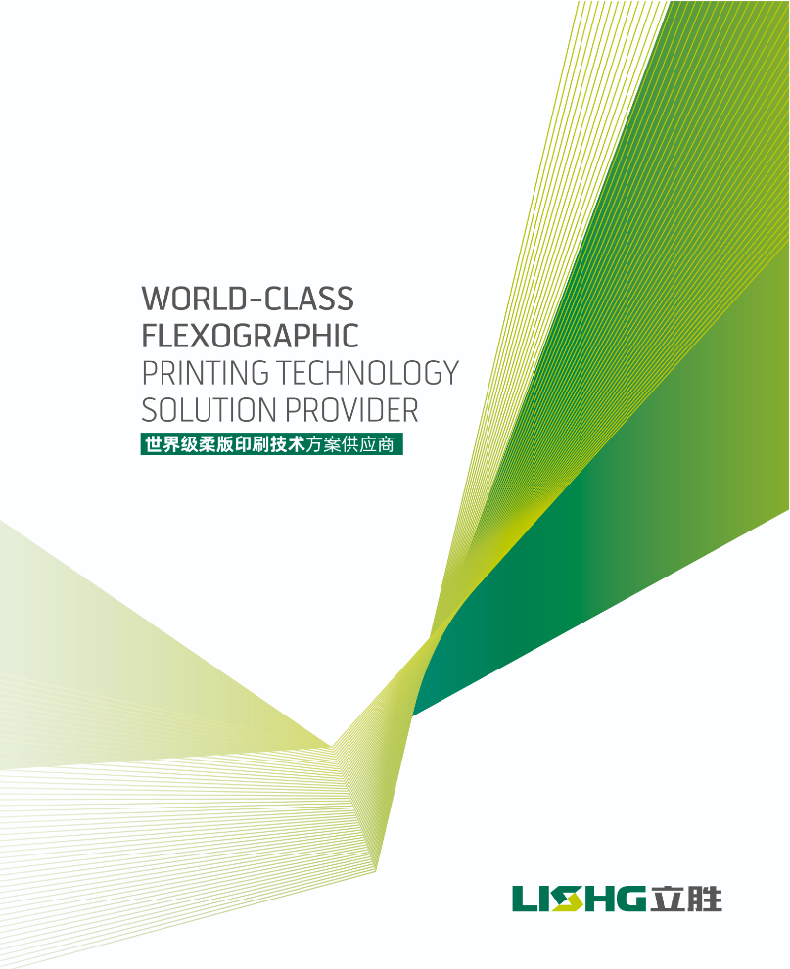
WENZHOU LISHENG PRINTING AND PACKAGING MACHINERY CO.,LTD

HONOR SERIES
Number of printing units 6-colors
Machine width 800 mm
Print repeat 300 – 1000 mm
^{Pritning speed max. 200 m/min}
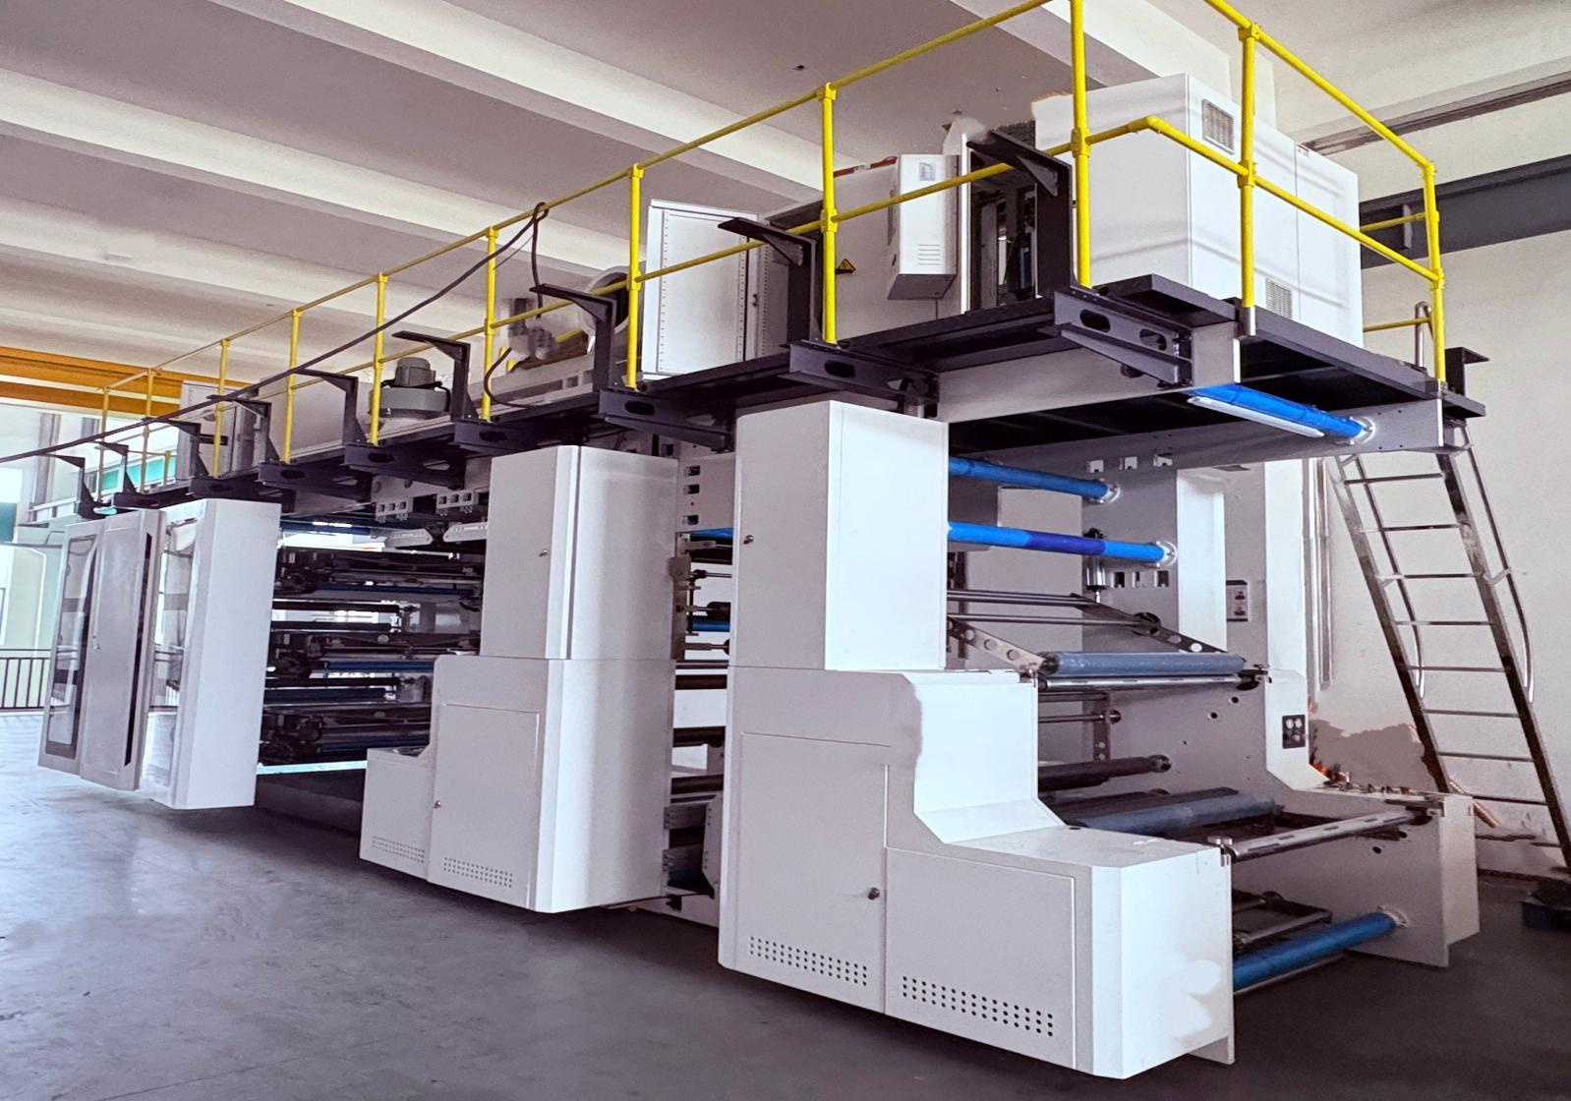

machine photo just for reference.

QUOTATION

To： Offer No:20260622LDD
Date:2026-6-22
The offer is valid for 15 days

Mark | Description&Quantity |  | Unit price | Total Amount
1 | MADE IN CHINA | UNIT | Fob(RMB) | Fob price (RMB)
 | Honor Series Servo Stack Type 6 Color 800mm Flexo Printing Machine + | 1 SET | 651,000 | 651,000
2 | 50cm(free) 60cm 70cm 80cm 90cm*6 | 30 SET | 3375 | 81,000
3 | coron | 1SET | 21000 | 21000
Total mount |  |  |  | 753,000

PAYMENT ITEM
30% IN ADVANCE
70% BEFORE LOADING THE MACHINE
Delivery date: within75working days after confirmed the advanced payment
Warranty: 24 months

Technical Specification
Model | Honor series
Material Feeding Width | 800mm
Max Printing Width | 760mm
Colors | 6 colors
Material | Paper
Thickness of plate | 1.14mm.1.7mm 2.28mm.2.84mm. 3.94mm  Customized is available
Max Machine speed | 230m/min
Max Printing speed | 150-200m/min(Depends on material thickness and printing pattern)
Register precision | ±0.2mm
Heating method | Electricity heating
Max. unwind diameter | 1200mm
Max. rewind diameter | 1200mm
Unwind Unit
Unwind Roller | Shaftless unwind
Max. Dia. of Unwind | Φ1200mm
EPC | Double roller web guide
Traction Unit
Traction transmission | Servo motor control
Printing Unit
Plate Roller | 300-1000mm
Material of Plate | Resin
Drive Type | Drive by servo motor
Color Register Type | Manual and remote fine tuning
Ceramic Anilox Roller | Ceramic Anilox Roller: 80-1000LPI
Frame thickness | 100mm
Bottom roller | servo motor driving
Printing unit in and out | servo motor control
5)Heating and Drying Unit
Type of Heating and drying | Blowing first then heating
6)Rewind Unit
Type of rewind | Friction rewind
Max. Dia. of Unwind(standard) | Φ1200mm
Total machine power | 130kw
Machine size | 10m*2.7m*4.3m

Part 1 Unwinding And Rewinding Unit
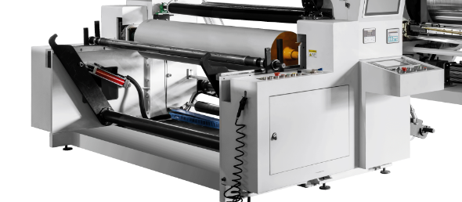
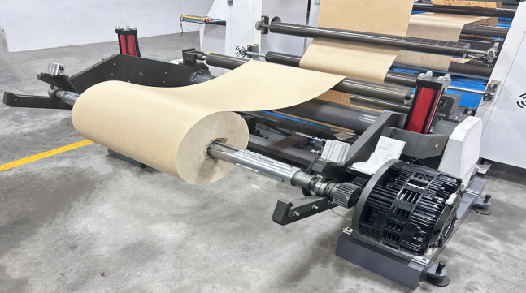
- This machine adopt active shaftless unwinding. The rewinder features a friction roller design for smoother material collection.

- Tension Control: air brake control the unwind ,the friction roll with awing arm for rewind e.

3.shaftless unwind of 3 inches 6inch and is clamped by a two-head cylinder disengagement system.

4.An automatic dual-roller process correction system is installed before printing, with adjustable left and right translation.

Part 2 Printing Unit
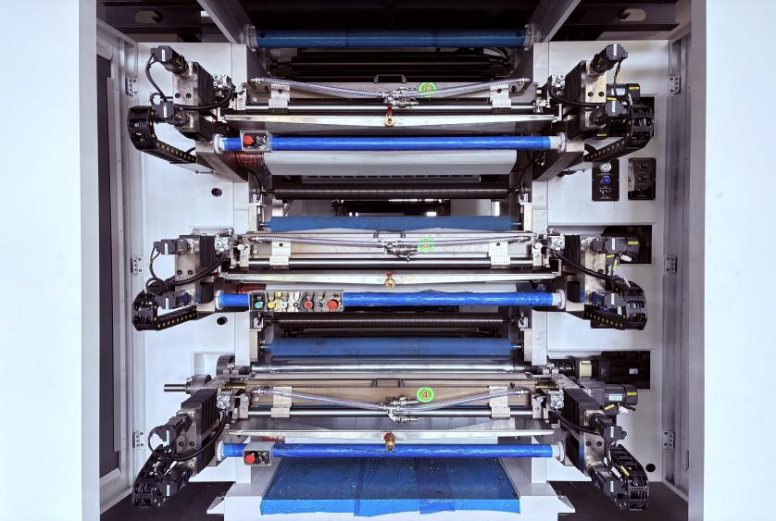 | 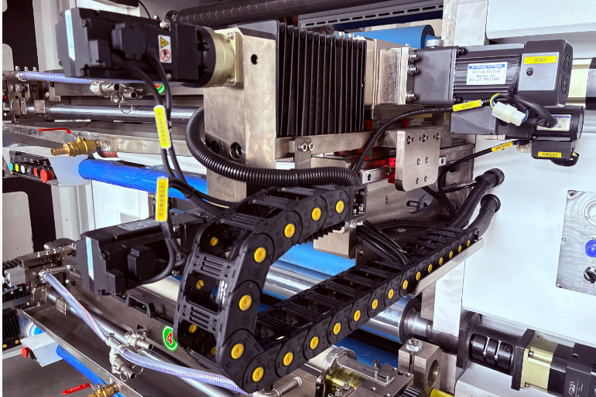
1.Full-width double-sided Printing Capability: Supports multiple printing modes, including6+0
(single- side), 3+3, 4+2,3+3(double-sided printing).

- A servo-driven feed system is employed, with four servo motors in each printing unit to
control the feed and movement of the anilox roller and printing roller. Precise control and calculation of the pressure for each printing unit enables rapid pre-pressure.

3.The guide rails utilize HIWIN guide rails with intermediate pre-pressure,eliminatinggaps,
increasing rigidity, and improving movement smoothness and precision.

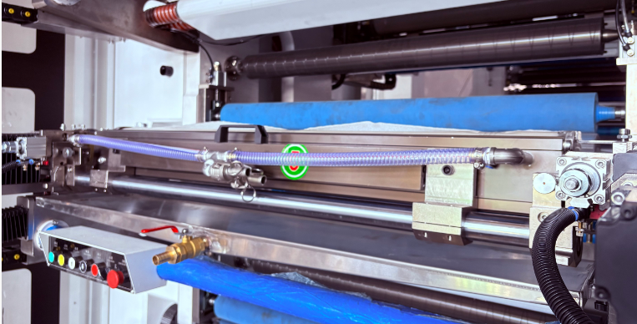 | 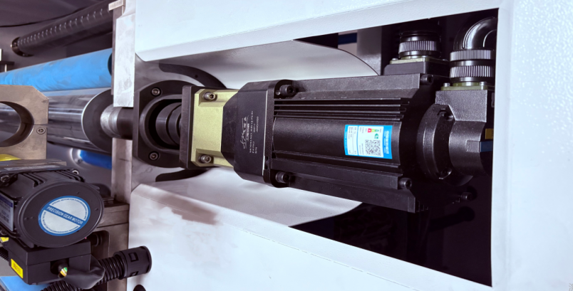
1.It adopts the latest generation of chamber doctor blade , equipped with venting function and pressure-controlled cylinder clamping function. It can effectively reduce ink splatter and the generation of air bubbles in the ink chamber.
2.The bottom cylinder driving by the servo motor control，adopts servo motor control system to quickly achieve 360-degree color registration，This provides more convenient operation and more stable printing, eliminating tedious manual operations.

Part 3 Drying Unit
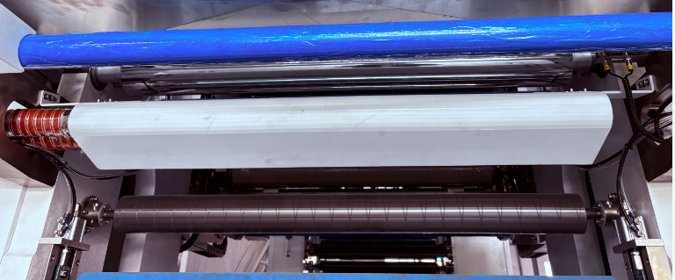
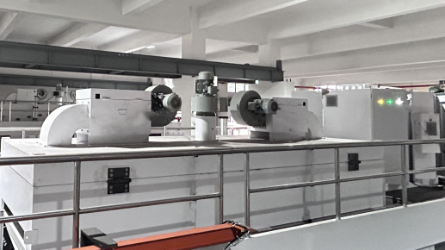
The machine is equipped with a recirculating air drying system that controls the inlet and outlet air volume to adjust the drying effect, achieve heat recovery and circulation, and save energy. A color-reversing drying oven is located at the bottom, and the dual fans use frequency converters to control the air volume to adapt to the drying requirements of different materials and speeds.

Part 4 Image static monitoring system

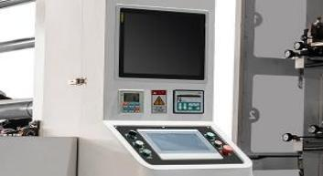 | 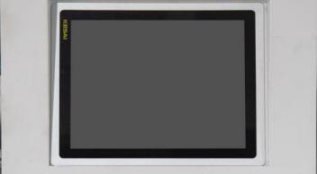
1.The static image monitoring system video inspector has a magnification of 3-30 (area magnification), displaying full screen. The image capture interval is automatically determined based on the position signal from the PG encoder/gear sensor. The camera's patrol speed is 1.0 m/min. The patrol range can be set arbitrarily based on the width of the printed material, enabling fixed-point monitoring or automatic reciprocating motion.

2. touchscreen human-machine interface PLC allows for data setting/modification, operating parameter monitoring/recording, and includes online help, alarm notifications, and historical data logging.

Main Component
Servo Motor |   Inovance
Relay |   Schneider
Ceramic anilox roller |   Yuncheng
Urgent Stop Switch |   Schneider
Button Switch |   Schneider
Low Friction Cylinder |   Fujikura Japan
The electromagnetic valve |   Airtac
Video inspetor |   Arise

Auxiliary equipment
Plate mounting machine
- The rack construction with the wallboard structure after high-strength holistic processing has great working stability and is durable in use

- The 650-line color high-definition camera can reach 70-times amplification ratio, present clear images, possess high resolution ratio, and substantially improve the precision of the plate

- The 19-inch high-resolution liquid crystal display provides clear and bright images and effectively alleviates the visual fatigue of operating workers.

- The maximum width of the equipment is within 2m, the longitudinal length is controlled at 0.7m or so, the height of the equipment is smaller than 1.7m and the drive is on the two sides of the wall-boards of the equipment. The operation, usage, repairing and maintenance are very convenient.
Noted:Optional,According to customer needs

Ultrasonic cleaning machine
- Quantity of vibrators: 36

- Working frequency of the cleanser: 40 KHz

- Total power of electric heater: 3KW

- Temperature control range: 30℃-100℃

- Ultrasonic power source: 25A／220V

- Heating power source of rinsing tank: 220V 25A
Noted:Optional,According to customer needs

Ink viscosity
Viscosity control system for an automatic viscosity control of ink with one type of solvent, with a vibration sensorial system. Note: System is designed with interface to connect to Buyer's supplied fresh solvent/water!
Noted:Optional,According to customer needs
AI online detector system
- Real-time defect detection and alarm，Identify various defects, ink defects, overprint errors, dirt spots and foreign objects, text lines, bar-code and QR code defects
Early defect detection reduces waste and ensures consistent printing quality Noted:Optional,According to customer needs
Corona treator
Additional corona treatment on the material surface to improve ink adhesion
Noted：optional -according customer required

After Sales
Installation:
The seller will send 1 engineer to install, test the production line and train customers’ workers in buyers’ factory. It will take 12 days for whole installation and training.
The buyer should cover engineers’ salary, visa cost, Round air tickets, accommodations, transportation in buyers’ country, food, medical care, safety cost, and related cost happens in buyers’ country. Also, the buyer should prepare enough labor, electric wire outside the control panel, Air Compressor and tools for installations.
Engineer’s Salary:
USD 120 /day, depending on how the engineer makes you satisfied. The date he arrives and leaves shall be counted as paid day.
Warranty:
Warranty period for the delivered equipment will be 12 months after completion of erection but not later than 18 months after shipment.
The above item does not include the parts, which have regular spares or the parts damaged from normal wear, abnormal operation, improper maintenance and inadequate civil works. The seller is not liable for any production loss under any circumstances.

Our company
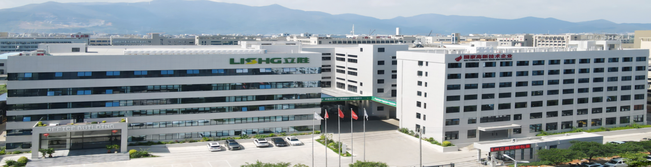
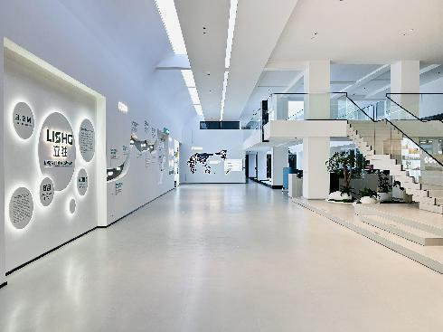 | 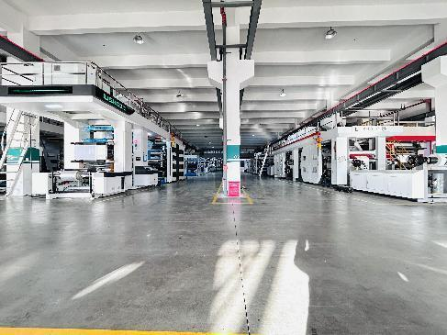
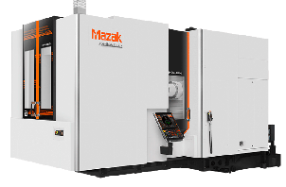
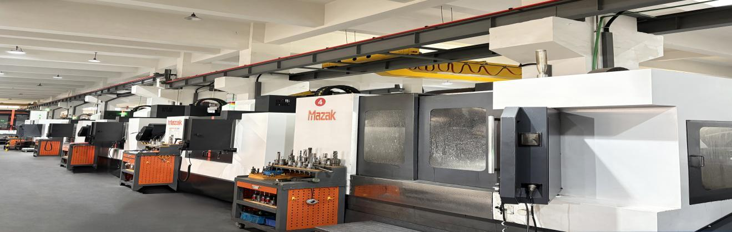
Wen zhou Li sheng Printing and Packaging Machinery Co., Ltd. boasts two decades of expertise in providing flexographic printing press solutions. As a reputable manufacturer, our product portfolio encompasses Stack type, Cl type, and Full Servo Sleeve options, tailored to meet the diverse printing requirements of packaging materials such as paper, film, non-woven fabric, and valve woven bags. Our business operations span across the globe, with a steadfast commitment to market orientation, technological innovation, and the delivery of premium-quality products.
To this effect, we possess a state-of-the-art factory, where we have invested significantly in the meticulous establishment of Mazak and gantry machining centers. This ensures that each component is meticulously crafted to attain unparalleled precision and guarantee the exceptional quality of our printing presses.

